I found an article about the summary of income tax data 2018 update at Tax Foundation. This article illustrates some key data of Federal Income Tax Data in 2016 aggregated by income percentiles. It used two ways to present data, graphical and tabular.

In the beginning, the author used sentences to describe some background information about the tax return in 2016. Then he started to present them by organizing data into tables, shown below.

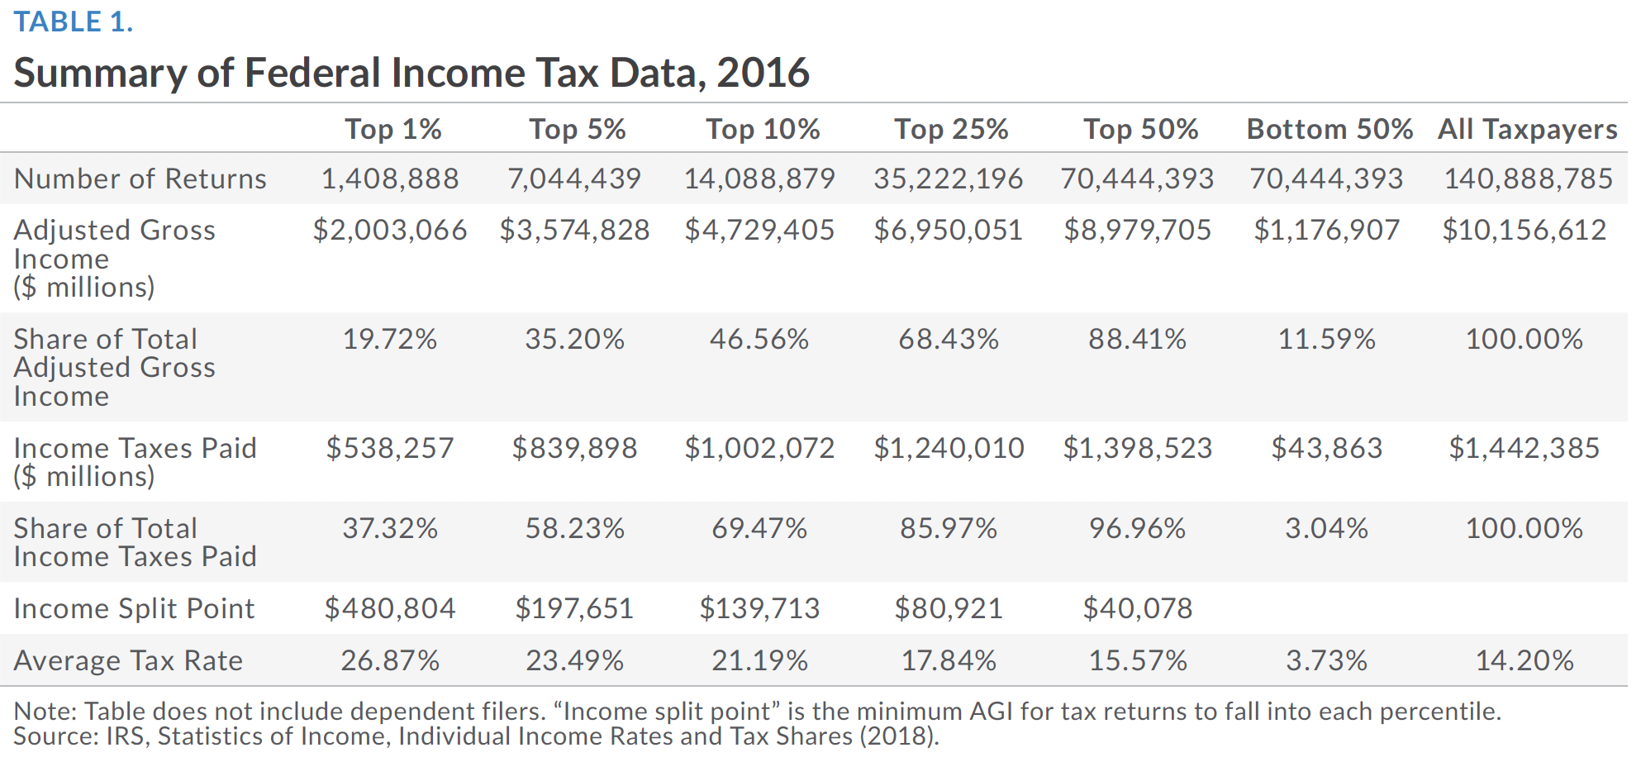

In this contingency table, we could clearly see the values or percentages of each level of categories. The first column records all the categories' names and the rest columns display the values/percentages.

Then the author tried to illustrate that high-income taxpayers paid majority. So here we've got a percentage chart to present these ordinary data, shown below.

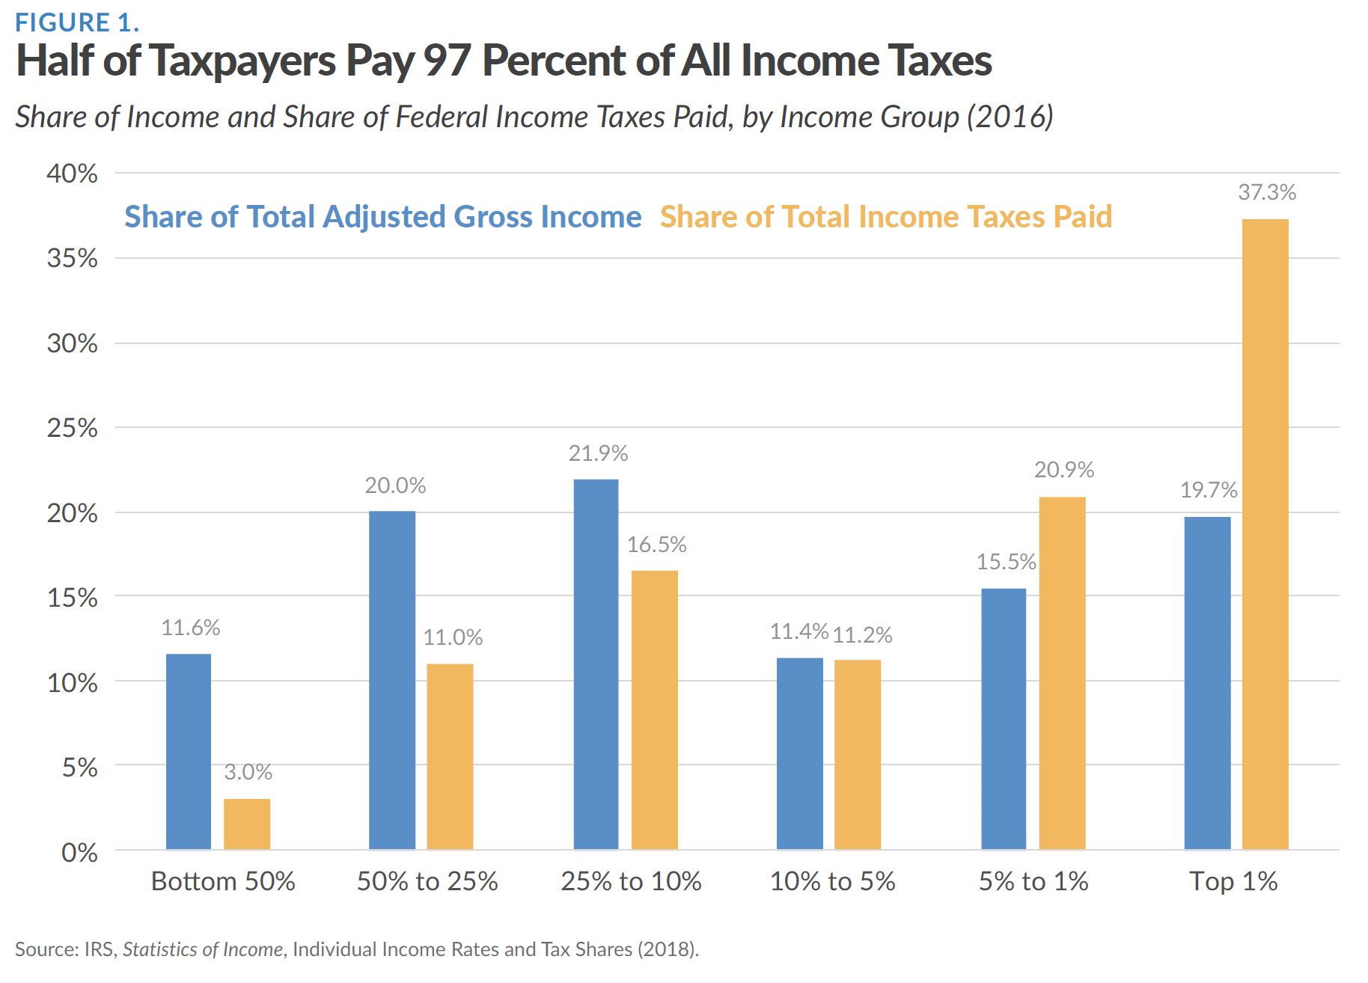

This chart shows and compares the results of both share of total AGI and share of total ITP. The regarding data has been aggregated by percentile: <50%, 50%-25%, and so on.

At the end of the article, there are several appendix tables to further present historical data of federal income tax return from 1980 to 2016 aggregated by taxpayers' percentile, shown below.

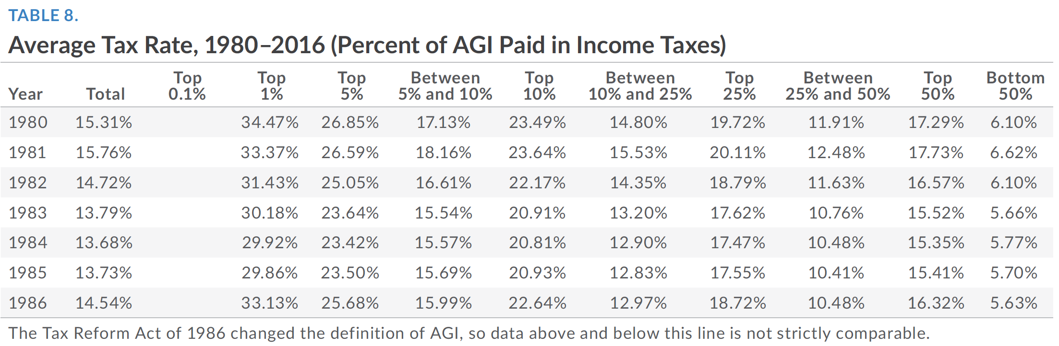

This table helped people to get a general idea of the trend of tax rate started almost 30 years ago. It also pointed out if there was a change of policy so we could better understand the comparison from previous data to nowadays.

In summary, the advantage of this article is that it used proper ways to illustrate categorical data, such as bar charts and tables. The disadvantage, on the other hand, is that it didn't contain any numerical method. Through the article, there were many comparisons between 2016 and 2015. But since we've got lots of historical data, we could get central tendency, variance, standard deviations and so on. After calculating all these statistics indexes, we could also use the graphical method to further illustrate data by using histograms, box plots, etc. Such an analysis would be much beneficial in showing the trend of federal income taxes in each percentile level.

Reference: BellaFiore, R. (2018, Nov 13). *Summary of the Latest Federal Income Tax Data, 2018 Update*. Retrieved from https://taxfoundation.org/summary-latest-federal-income-tax-data-2018-update/